
9:20 PM
4/26/2026
1001428105
Joel Pam Pam

Requirements Summary:
This project focuses on doing half precision floating point addition and subtraction based on the IEEE 754 standards. Inputs A and B are entered in as Hex values to represent the 16 bit binary numbers and the output is also displayed as a Hex value on the hex display.
Input Requirements:
- Input must be entered on the CSE 4 x 4 keyboard
- Input must be entered in binary IEEE format which can be done by entering in as a HEX value. For example, 3.75 in IEEE binary format is 0100001110000000 which should be entered in as 4380 on the keyboard
- Operand A should be entered by keying in the number and pressing key 2 on the Hex Board
- Operand B should be entered by keying in the number and pressing key 3 on the Hex Board
- Results R will be computed by pressing key 4 on the Hex Board
- Key 0 on the DE10 can be used to reset
Output Requirements:
- Operand A will be display on the Hex display in hex according to IEEE 754 half precision format
- Operand B will be displayed on the Hex display in hex according to IEEE 754 half precision format after pressing key 3
- Result R will be displayed on the Hex display in hex according to IEEE 754 half precision format after pressing key 4
- LEDR0 on the DE10 will showcase the Overflow Flag
- LEDR1 on the DE10 will showcase the Underflow Flag
Complete process to use the floating adder/subtractor on the DE10:
- Enter operand A in hex based on the IEEE 754 half precision format and press key 2. This will display A on the Hex display
- Enter operand B in hex based on the IEEE 754 half precision format and press key 3. This will display B on the Hex display
- Finally the Result will be displayed on the Hex display after pressing key 4 on the hex board.
Description of any added features:
No Additional Added features
-BONUS: Early Submission
-BONUS: Subtraction
-BONUS: Overflow and Underflow Flags
Organization Diagram:
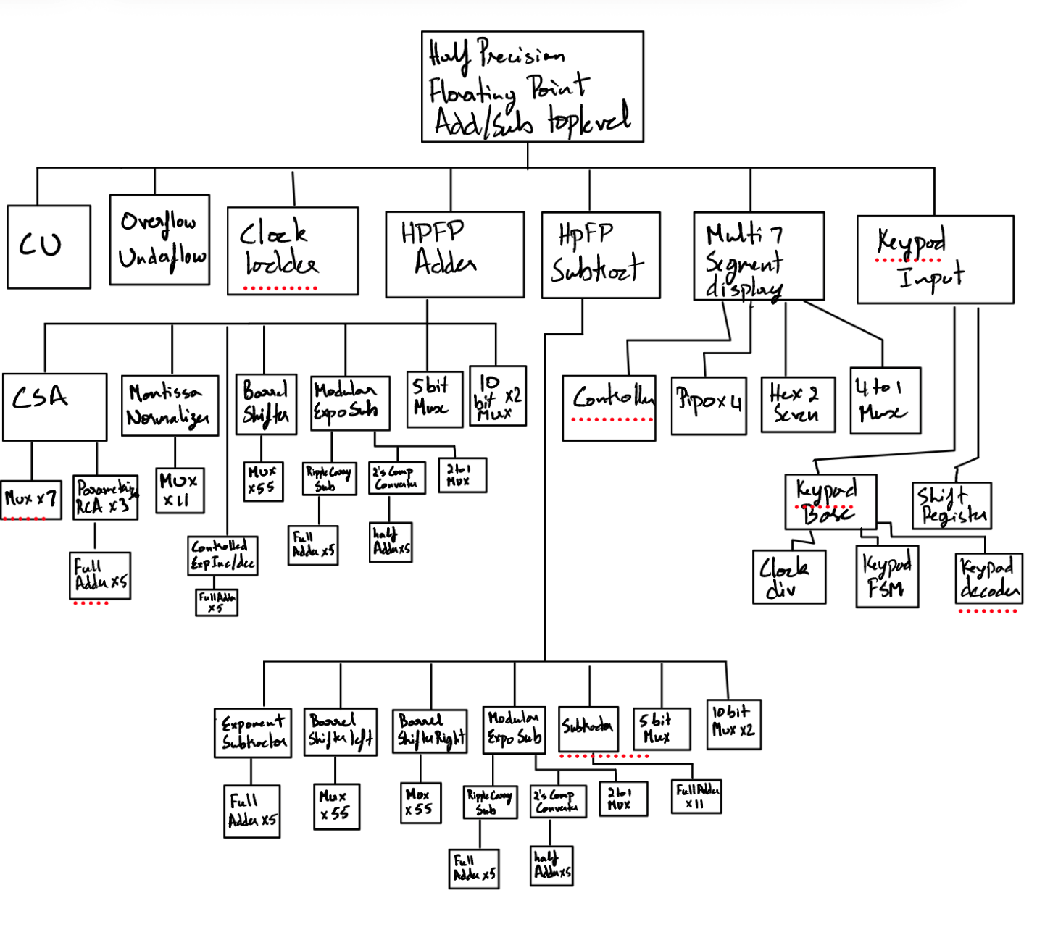

Test Results:
- Summary:
A | Hex value of A | B | Hex value of B | Result (R) | Hex value of R | Overflow | Underflow
3.75 | 0x4380 | 5.125 | 0x4520 | 8.875 | 0x4870 | 0 | 0
3.75 | 0x4380 | -5.125 | 0xC520 | -1.375 | 0xBD80 | 0 | 0
-3.75 | 0xC380 | 5.125 | 0x4520 | 1.375 | 0x3D80 | 0 | 0
9.5 | 0x48C0 | 0.5625 | 0x3880 | 10.0625 | 0x4908 | 0 | 0
9.5 | 0x48C0 | -0.5625 | 0xB880 | 8.9375 | 0x4878 | 0 | 0
-9.5 | 0xC8C0 | -0.5625 | 0xB880 | -10.0625 | 0xC908 | 0 | 0
125.125 | 0x57D2 | -12.0625 | 0xCA08 | 113.0625 | 0x5711 | 0 | 0
1000 | 0x63D0 | 1049 | 0x6419 | 2050 | 0x6801 | 0 | 0
65504 | 0x7BFF | 65504 | 0x7BFF | +∞ | 0x7C00 | 1 | 0
-65504 | 0xFBFF | -65504 | 0xFBFF | -∞ | 0xFC00 | 1 | 0
0.0000610948 | 0x0401 | -0.00006103515625 | 0x8400 | +0 | 0x0000 | 0 | 1
0.000244140625 | 0x0C00 | -0.00024437904358 | 0x8C01 | -0 | 0x8000 | 0 | 1

- Demonstration
https://youtu.be/Am9OUKdBFNQ?si=iWIaEgJJ6qxy8XxN
SystemVerilog Code:
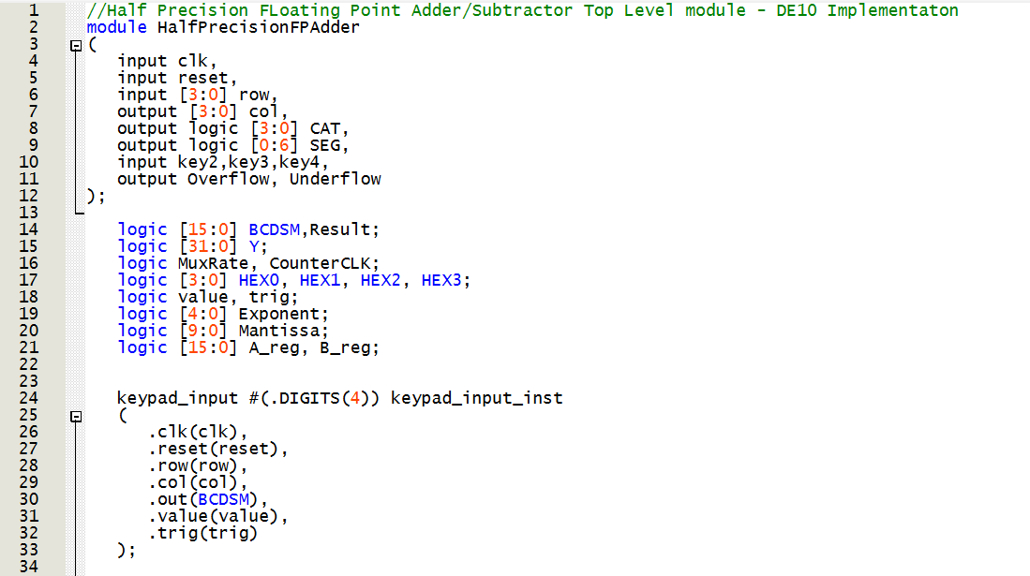
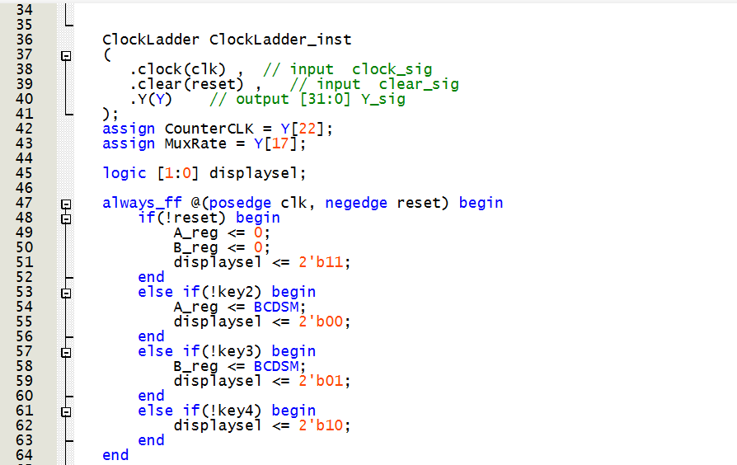
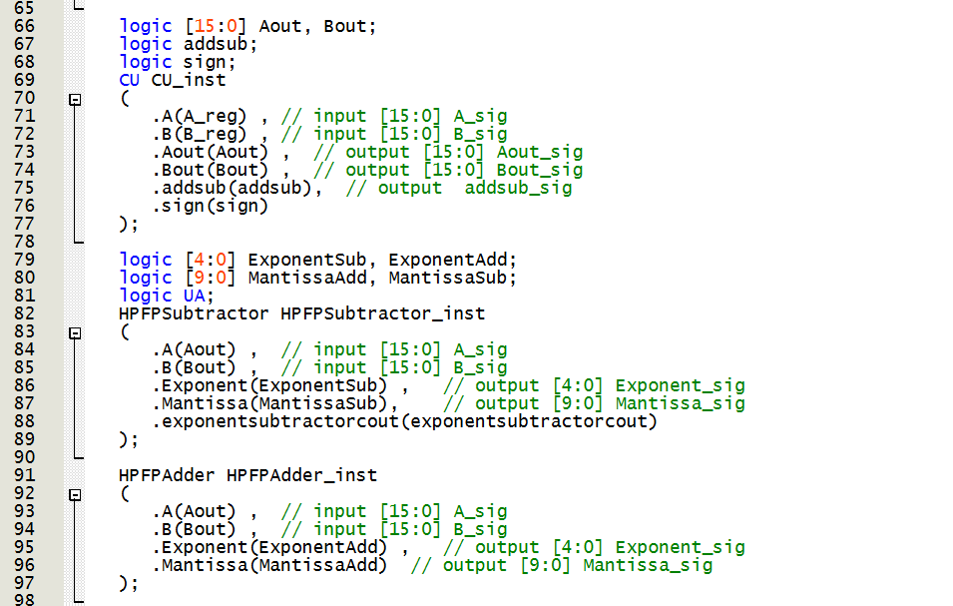
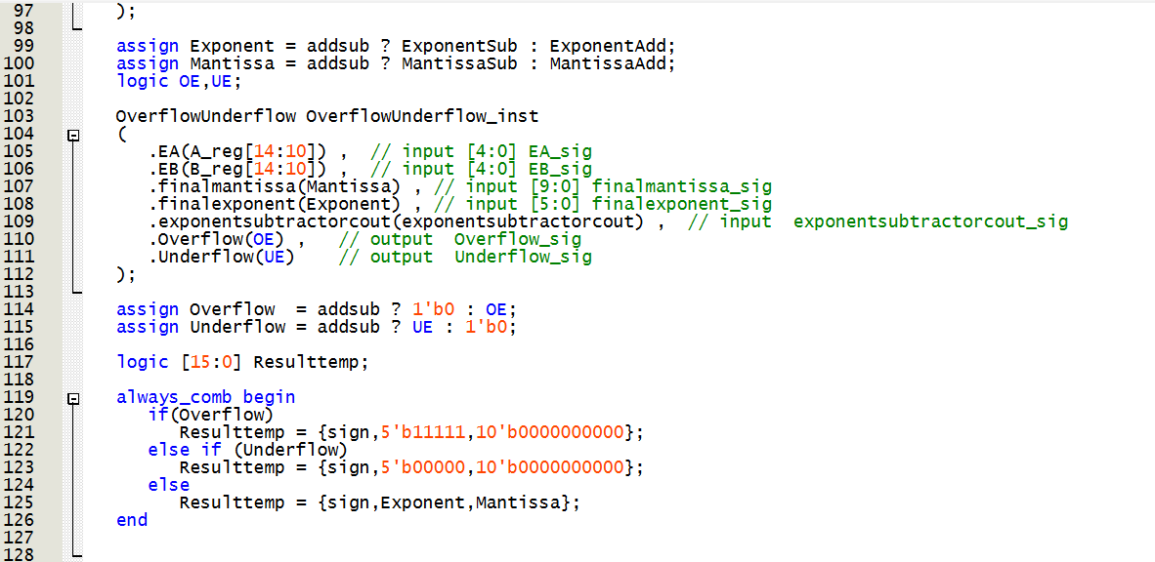
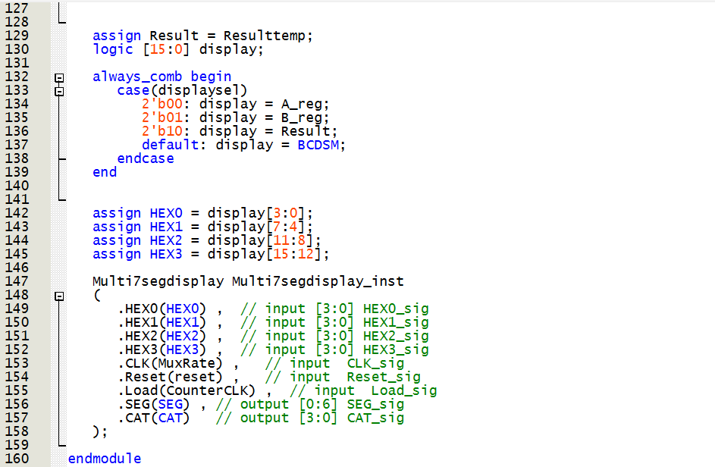
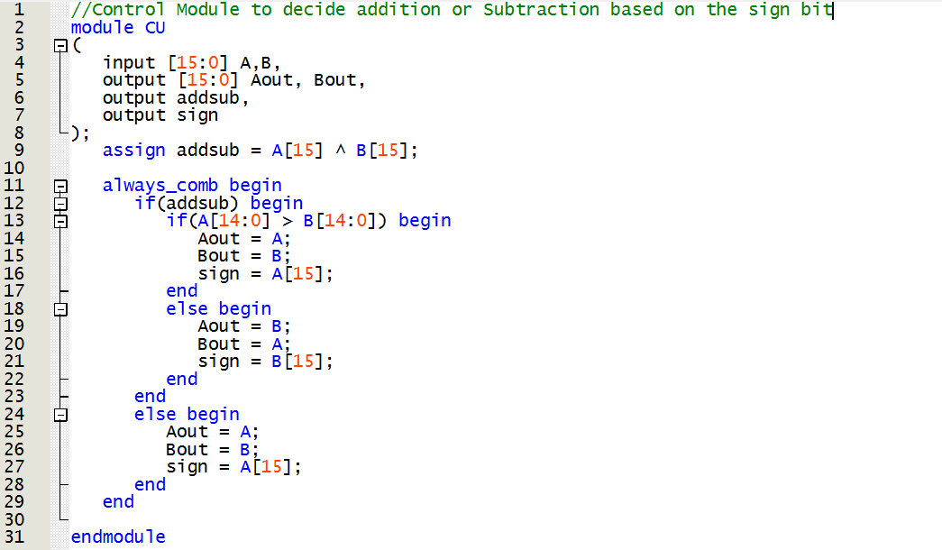
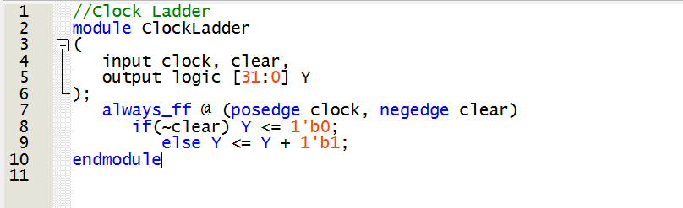
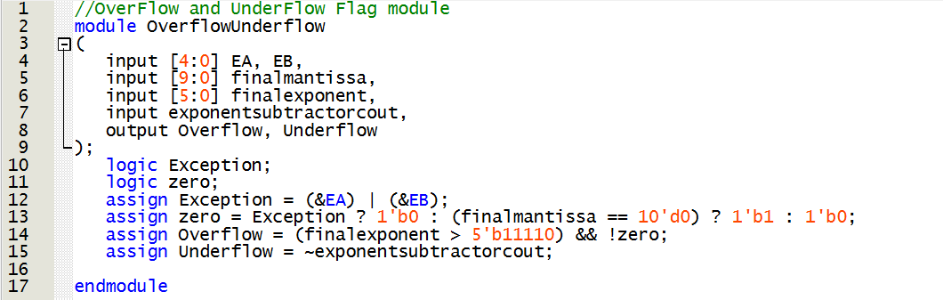
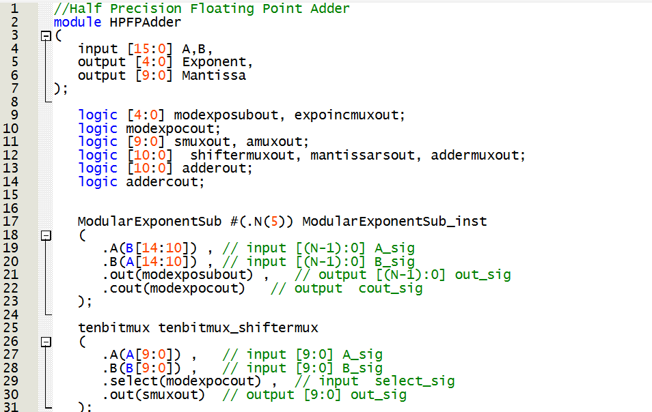
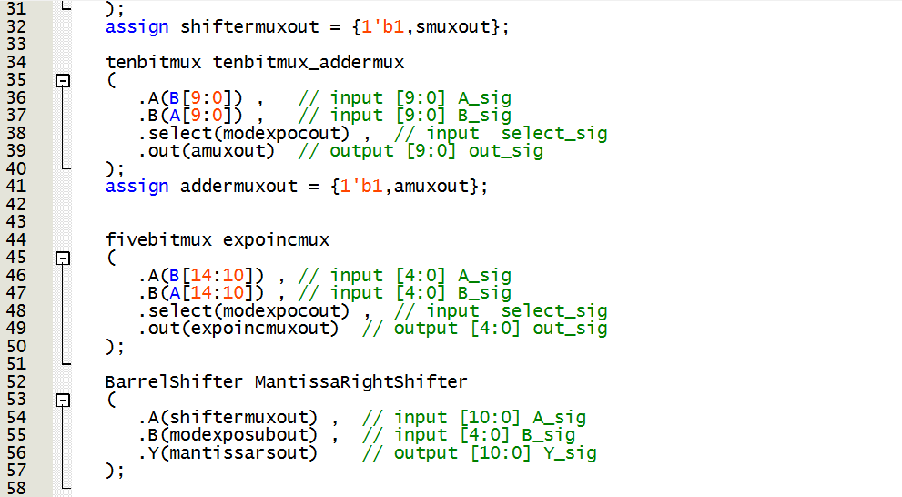
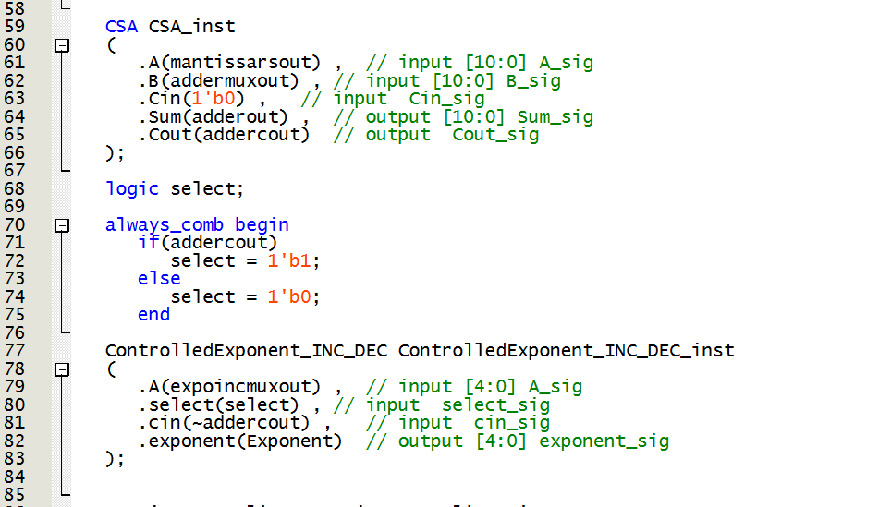
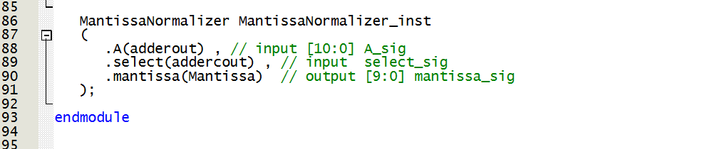
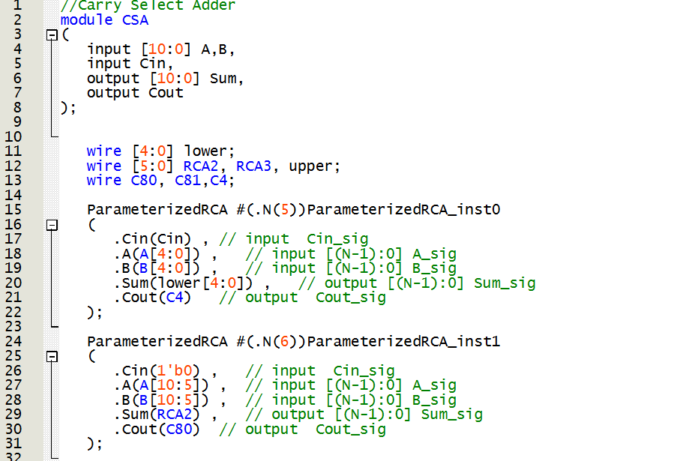
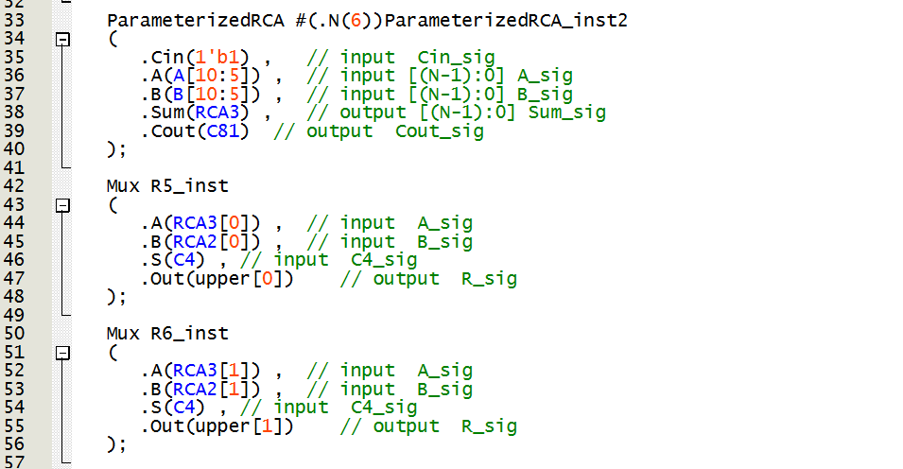
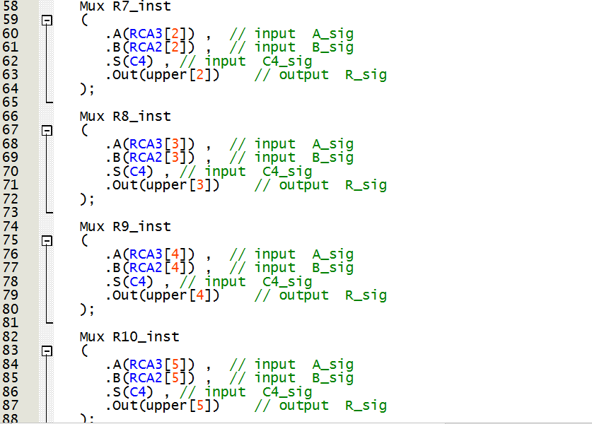
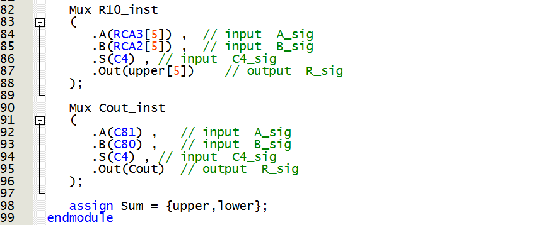
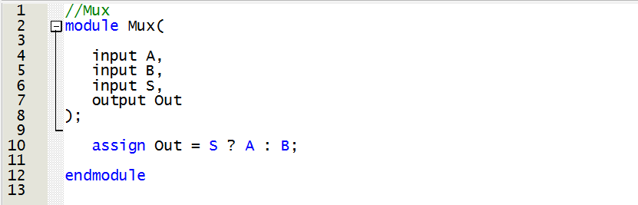
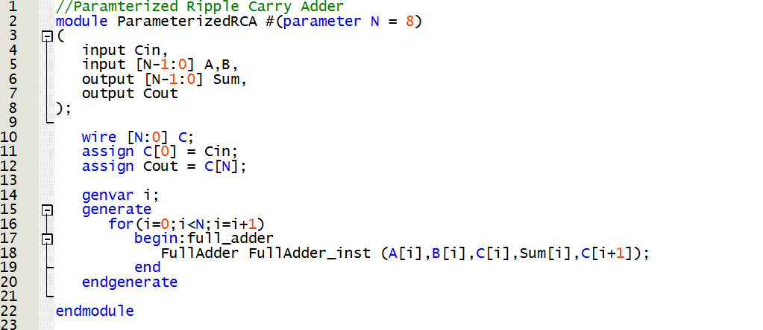
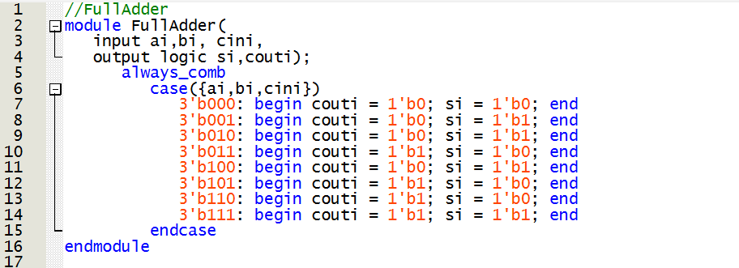
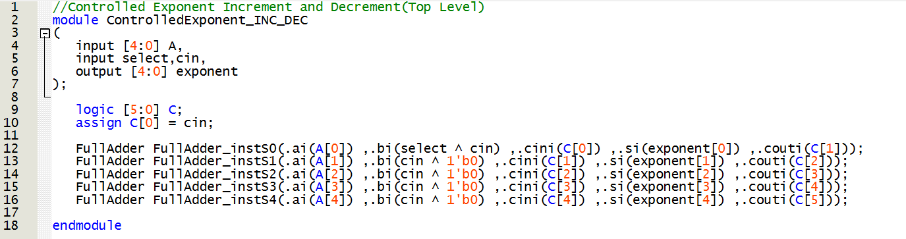
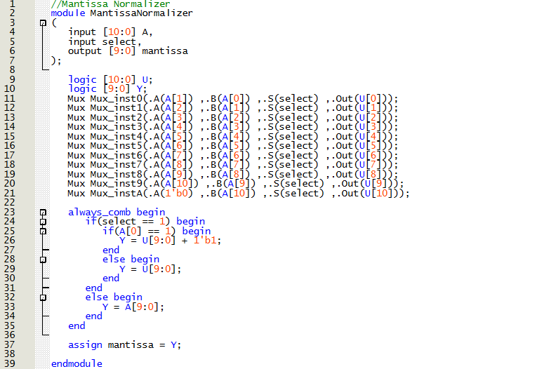
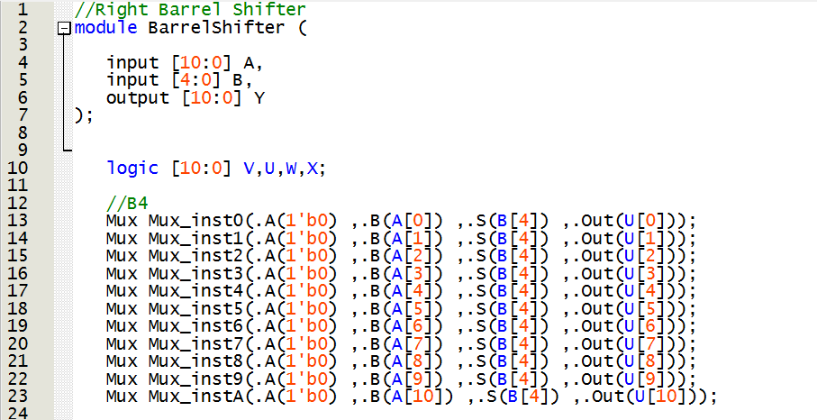
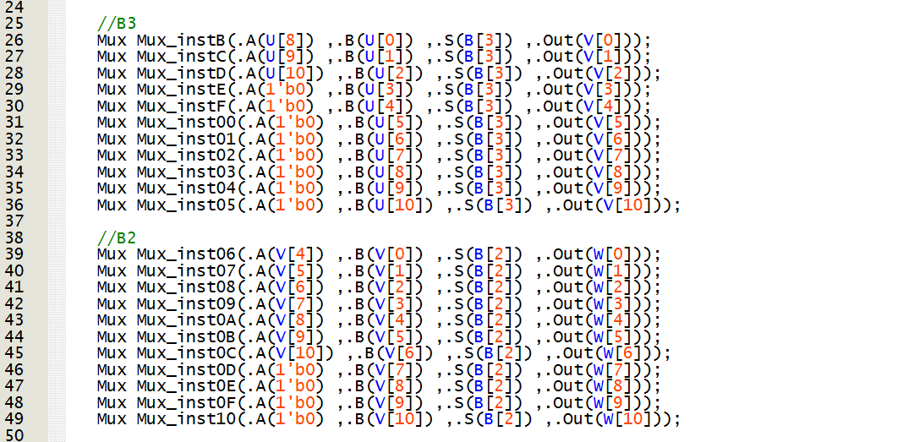
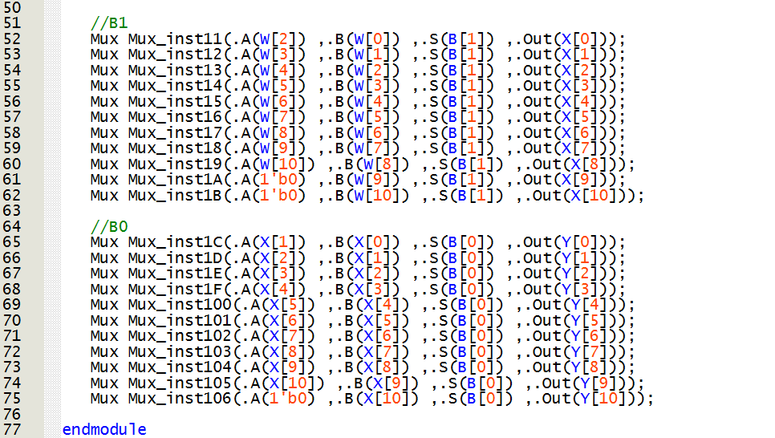
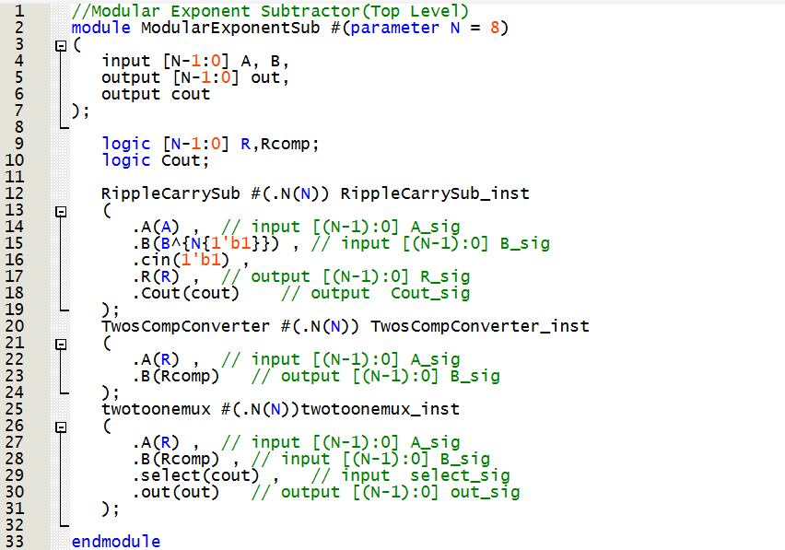
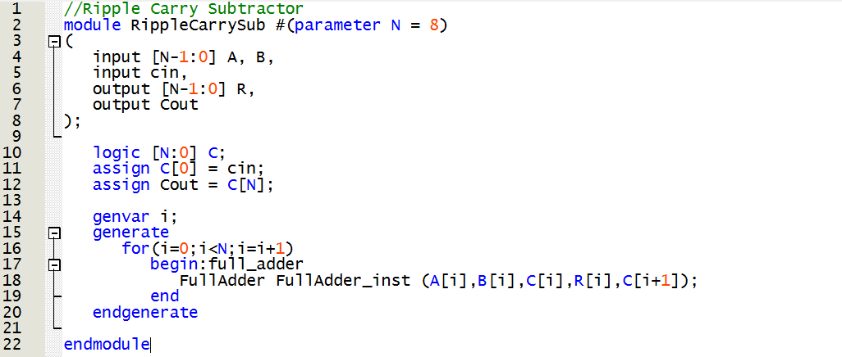
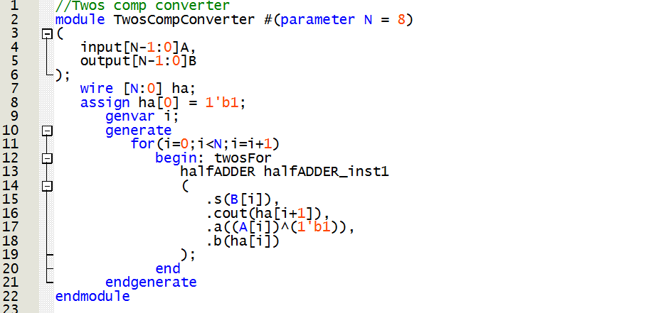
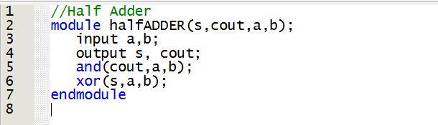
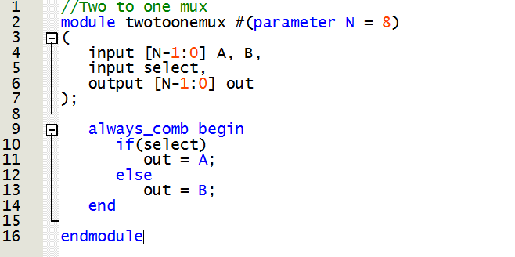
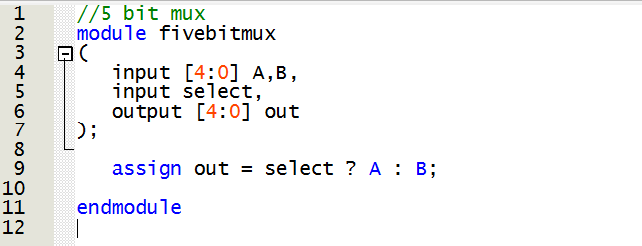
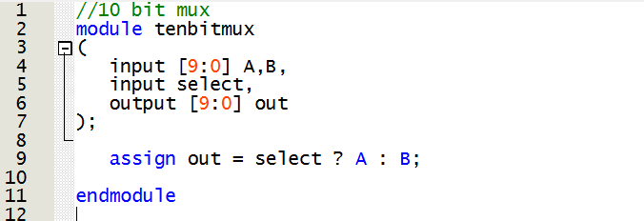
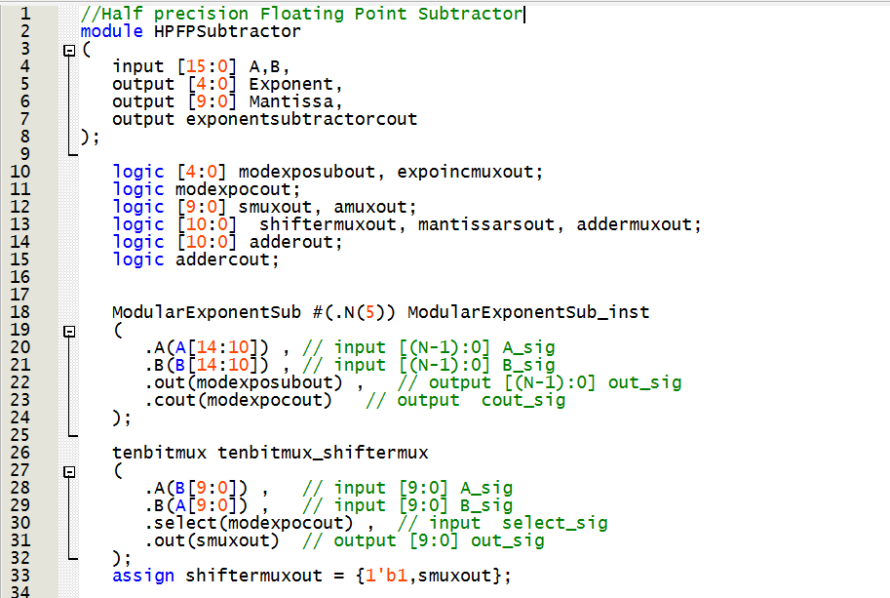
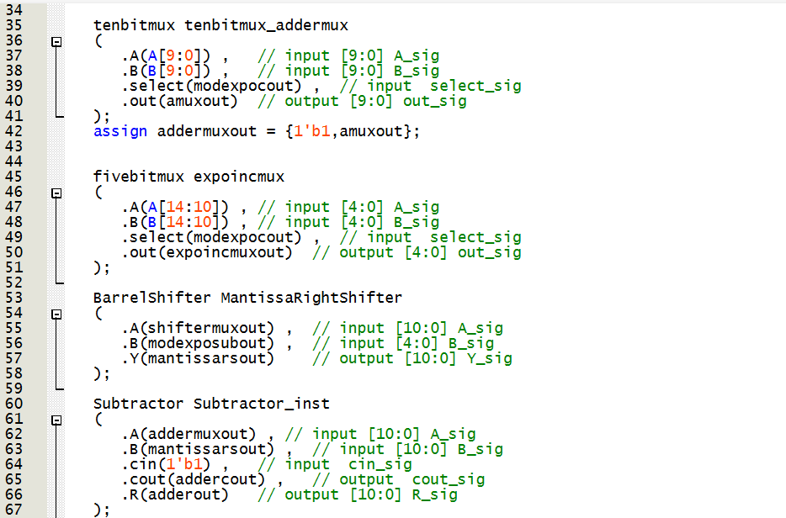
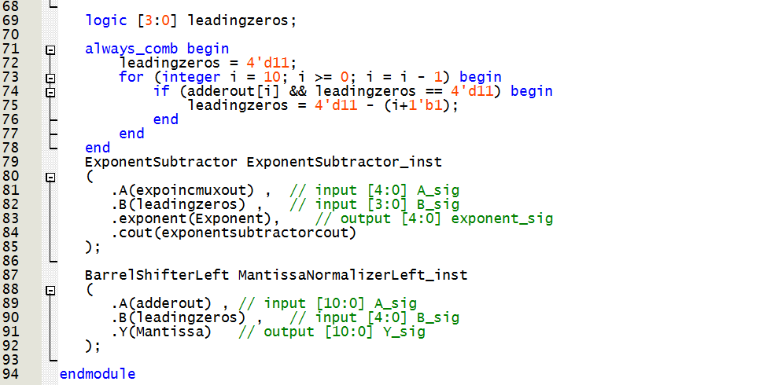
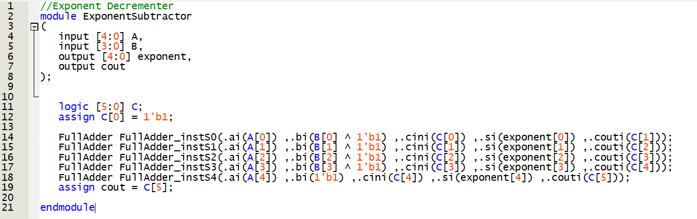
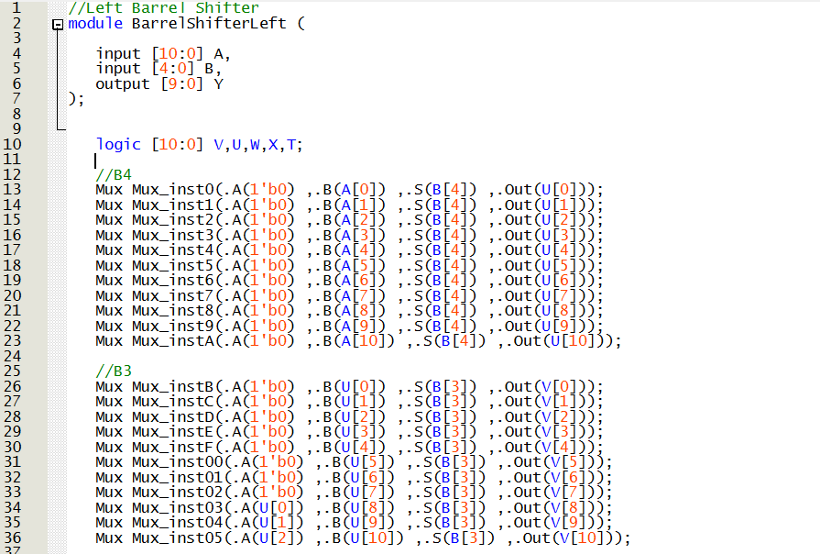
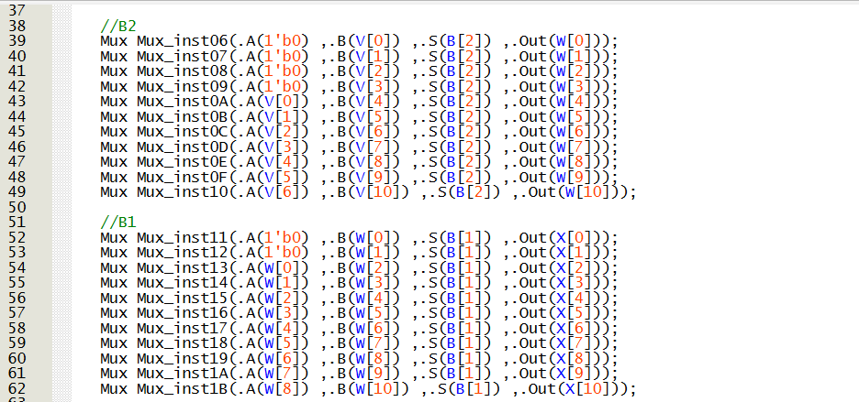
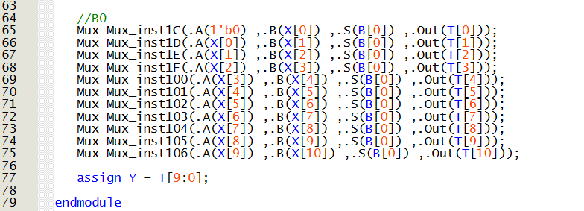
*Right Barrel Shifter,5bit Mux, 10bit Mux and Modular Exponent Subtractor are the same as the one’s used in HFPFAdder with the code presented above
